MANUSCRIPT DATA IDENTIFICATION FORM

Please fill out this form on the computer and store it in the directory with your programs.

Title: Tailoring Recurrent Neural Networks for Optimal Learning

Senior Author: Yang-Yu Liu

Authors: Pau Vilimelis Aceituno, Yan Gang, Yang-Yu Liu

Date: 28th Feb 2020 Directory with Programs: https://github.com/pvili/EchoStateNetworks_NetworkAdaptation/tree/master/Tailoring%20Recurrent%20Neural%20Networks%20for%20Optimal%20Learning

Table/Figure # Program Name Date of Run
Fig. 2 Script in matlab 27th Feb 2020
Fig. 3 Script in matlab 27th Feb 2020
Fig. 5 Script in matlab 27th Feb 2020
Fig. 6 Script in matlab 28th Feb 2020
Continued on back page

Data in Text(pg/para) Program Name Date of Run
Mackey-Glass Time Series Matlab 27th Feb 2020
Laser Intensity Time Series Matlab 27th Feb 2020
Spoken Arabic Digit Recognition Matlab 27th Feb 2020
New Derived Variables Program Name Date of Run
Special Files Program Name Date of Run
Study Documentation Files

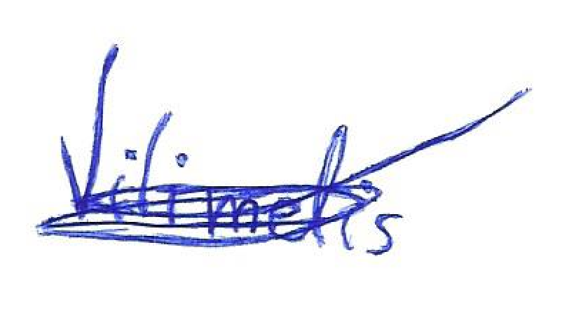
Programming Review by:

Pau Vilimelis Aceituno |  |  |  | 28th Feb 2020
Programmer (Type or Print) Programmer (Signature) Date

Pau Vilimelis Aceituno |  |  |  | 28th Feb 2020
Investigator (Type or Print) Investigator (Signature) Date

